**The School District Analysis**

**Overview:**

The school board found some discrepancies in the student_complete.csv file. The file shows that reading and math grades for Thomas High School ninth grade has been altered. Although school board does not know the full extend of the academic dishonesty and ask Maria to help. Maria wants to change the math and reading scores for Thomas High School 9th grades to NaNs while the rest of data stays the same. Maria wants to run the school district analysis after changing the scores for Thomas High School 9th grade.

**Results:**

* The District summary affected slightly by removing 9th math and reading scores for Thomas high school’s scores. Average math and reading scores went down and it affected the passing scores for both math and reading. Overall passing percentage went down as well.



* The school summary did not get affected by taking out Thomas high school math and reading scores.

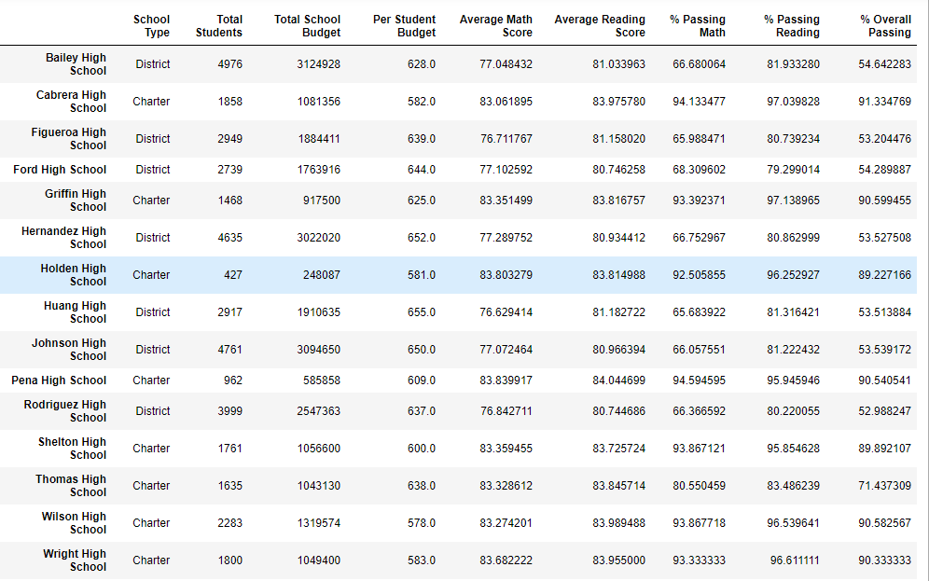

* Thomas high school performance related to other school was average. By the overall passing percentage, the school was on 8th no with 71.44%.
* Math and reading scores by grade: only affected Thomas high school because it shows Nan in the 9th grade scores.
* Scores by school spending: the spending was high compare to the passing scores
* Scores by school size:
* Scores by school type: the math average and reading scores were 83% which bring math and reading passing percentage to 92% and 95%. The overall percentage is 88%. With the math and reading scores removed from one school affected the whole charter school community

**Summary:**

* The overall performance of charter schools went down by replacing the grades for math and reading.
* Total school spending per student was high
* The top 5 school list was change
* Thomas high school performance